1-Download and Install SQL server Reporting Service
https://www.microsoft.com/en-us/download/details.aspx?id=55252
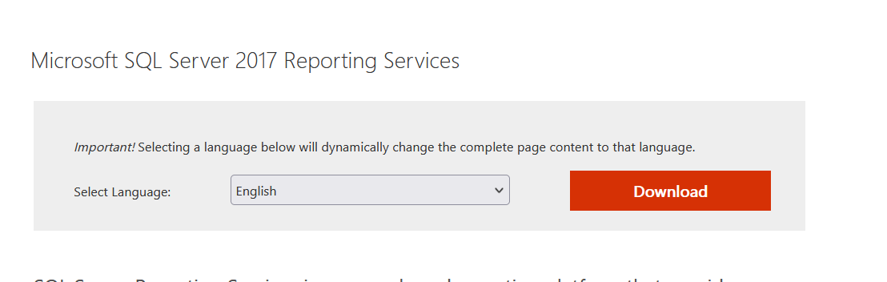
2- Download VS Community
https://visualstudio.microsoft.com/downloads/
3- Select SQL Server Data Tools under Data storage and processing in the list of workloads.
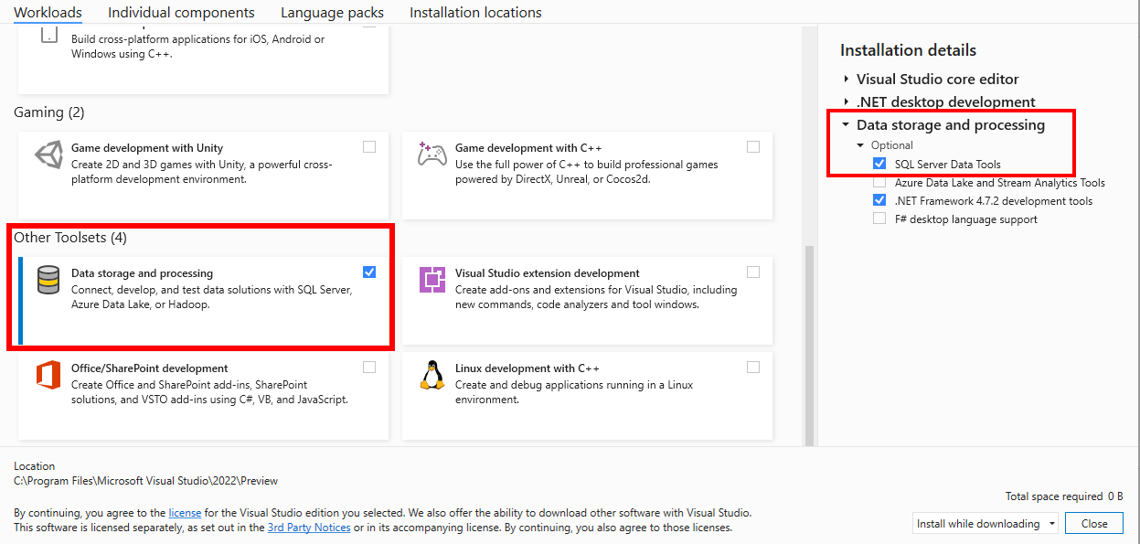
4- after installing VS Restart PC
5-Now We Need to Enable BI Projects ON Visual Studio but we should ensure that VS and SQL Server are closed
6- Download and Install Integration service Project
https://marketplace.visualstudio.com/items?itemName=SSIS.MicrosoftDataToolsIntegrationServices
7-after installation Restart PC
8 -Download and Install Analysis services Projects
https://marketplace.visualstudio.com/items?itemName=ProBITools.MicrosoftAnalysisServicesModelingProjects2022

9- after installation Restart PC
10- Download and Install Reporting service Project
https://marketplace.visualstudio.com/items?itemName=ProBITools.MicrosoftReportProjectsforVisualStudio2022
11- after installation Restart PC
12- Download SQL Server Developer Edition
https://www.microsoft.com/en-us/sql-server/sql-server-downloads
13-Download then double click on
SQL2025-SSEI-StdDev.exe
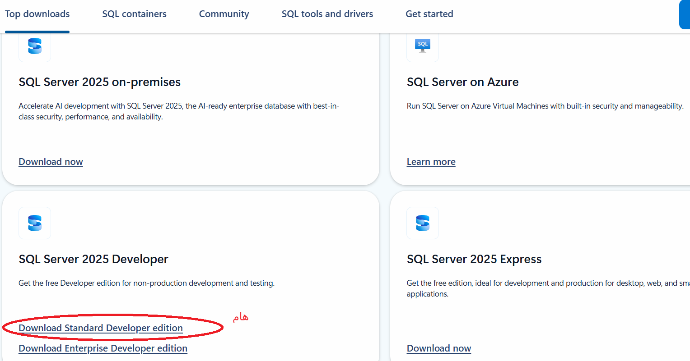14-choose custom
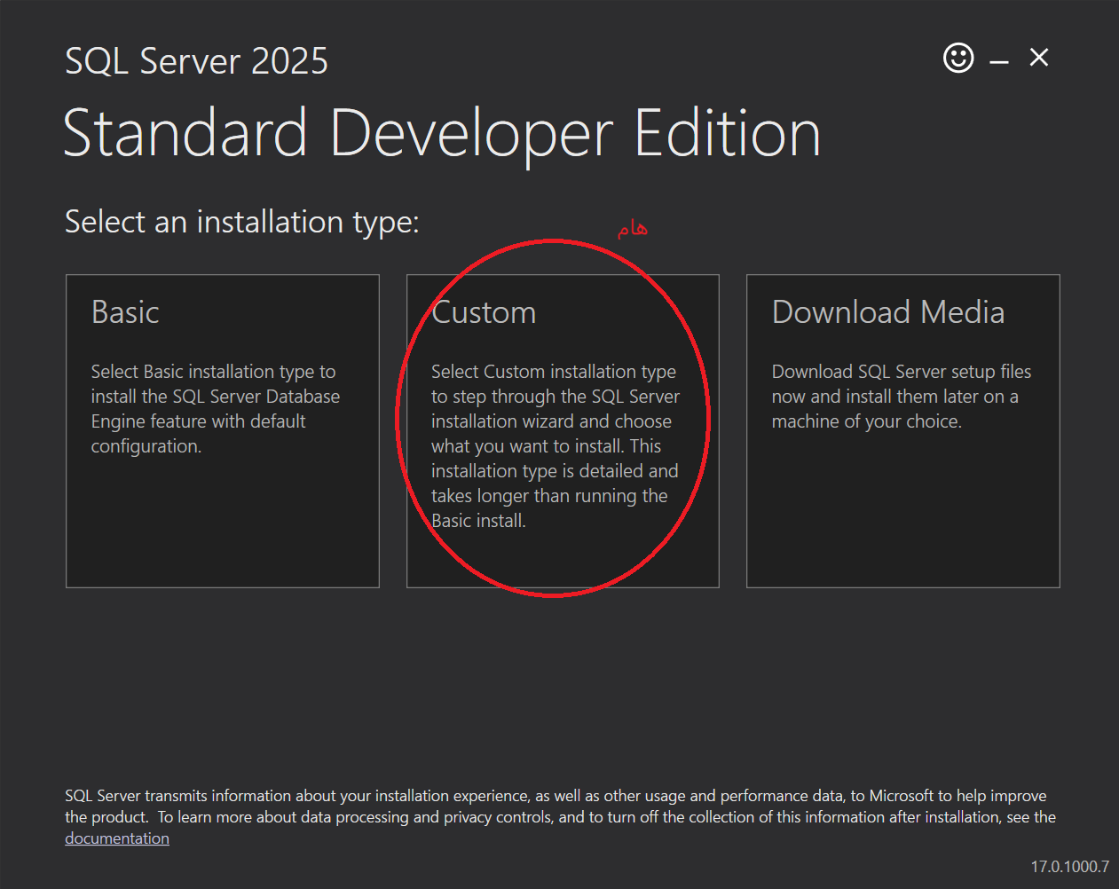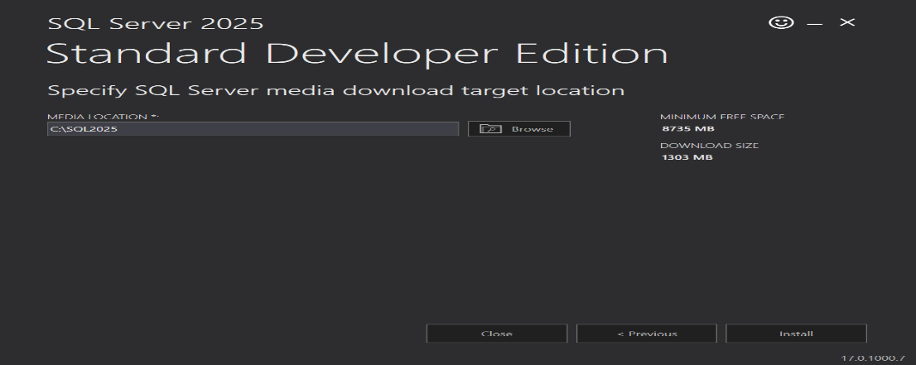
15-choose install to download .exe
16- we will continue setup configuration during course
Good Luck

